**Presentation of Findings**

**Figure 1: Bar graph showing the numbers of persons infected with disease in Stabroek**

|  |  |  |
| --- | --- | --- |
| **Disease** | **# of Responses** | **%** |
| Food diseases | 3 | 10.34% |
| Vector diseases | 7 | 24.14% |
| Water diseases | 7 | 24.14% |
| Viral infections | 12 | 41.38% |
| **Total** | **29** | **100%** |

**Figure 2: Table showing the diseases deemed prevalent in Stabroek by respondents**

**Figure 3: Pie chart showing the main causes of disease as identified by respondents**

**Figure 4: Bar graph showing the effects of disease on residents of Stabroek**

|  |  |  |  |  |
| --- | --- | --- | --- | --- |
|  | **Tally /number of responses for activity** | | | |
| **Activity** | **Landfills** | **Polluted Waterways** | **Main Road** | **Businesses** |
| Avoid uncooked food | **| | |** | **| |** | **| | | |** | **| | | |** |
| Avoid unfiltered water | **~~| | | |~~** | **| | | |** | **| | | |** | **| | | |** |
| Keep fingernails short and clean | **|** | **| | | |** | **| | |** | **|** |
| Use sanitary toilets | **~~| | | |~~** | **| | | |** | **~~| | | |~~** | **| | | |** |
| Dispose wastes properly | **| |** | **| | |** | **| | |** | **| | |** |
| Avoid consuming food from vendors | **-** | **-** | **| |** | **-** |
| Wash hands before eating | **~~| | | |~~** | **| | | |** | **~~| | | |~~** | **| | | |** |
| Wear insect repellant | **-** | **-** | **-** | **-** |
| Wear long sleeves outdoors | **| | | |** | **|** | **| | |** | **| |** |
| Do not leave windows and doors open | **-** | **-** | **-** | **-** |
| Dump all water-holding containers regularly | **~~| | | |~~** | **~~| | | |~~** | **~~| | | |~~** | **~~| | | |~~** |

**Figure 5: Tally chart showing the general hygienic activities exercised by residents in Stabroek**

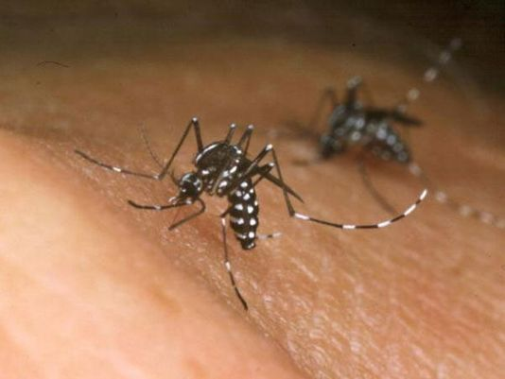

**Figure 6: Photograph of vector (mosquito) feeding on human blood**

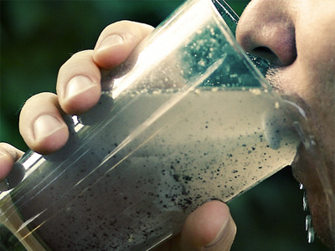

**Figure 7: Photograph of a human drinking contaminated water**